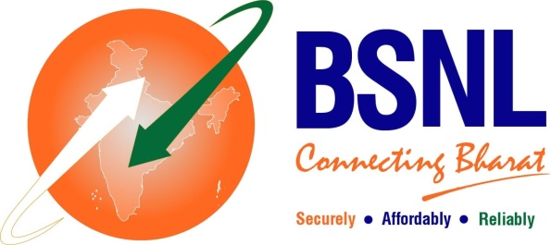

**BSNL CHENNAI TELEPHONES**

*( Circular R&C-CFA No. 15/25-26 dtd 03/07/2025)*

**MONSOON OFFER**

BSNL is happy to introduce **MONSOON offer** for **New FTTH** connections booked under FTTH plans **Fibre Basic Neo** and **Fibre Basic**. In this offer, the customer can avail:

1. Rent free FTTH during the first calendar month.
2. A discounted FMC of Rs. 399 for the subsequent three months.
3. This offer is also available only for new customers opted monthly subscription of above plans.
4. This offer is available from 01 July 2025 to 30 Sep 2025.

Hurry Book your FTTH connection now!!

<https://bookmyfiber.bsnl.co.in/> or connect with us (dial or whatsapp) on 1800 4444